**ANALYSIS SUCCESS RATE OF BPAL/M THERAPY FOR DRUG RESISTANT TUBERCULOSIS AT DR. H. ABDUL MOELOEK GENERAL HOSPITAL, LAMPUNG PROVINCE, 2024-2025**

**Chicy Widya Morfi,1 Retno Ariza Soemarwoto,1 Tetra Arya Saputra,1 Laisa Azka,1 Adityo Wibowo, 1 Naufal Rafif Putranta1**

Department of Pulmonology and Respiratory Medicine, Faculty of Medicine, Lampung University

Email correspondence [chicy.widya22@gmail.com](mailto:chicy.widya22@gmail.com)

**ABSTRACT**

**Background**: Tuberculosis (TB) is a preventable and usually curable disease. In 2023, tuberculosis causes an estimated 1.25 million deaths worldwide. Globally, there are an estimated 450,000 new cases of multi-drug resistant (MDR) tuberculosis or rifampicin resistant (RR) tuberculosis by 2021. Challenges in the treatment of drug-resistant tuberculosis (DR-TB) include a longer treatment period using second-line OAT with various side effects that affect patient treatment adherence. Therefore, shorter treatment with fewer drugs is needed to overcome these challenges. Since 2022, WHO has announced treatment with Bedaquiline, Pretomanid, Linezolid, and Moxifloxacin (BPaL/M) to treat drug-resistant tuberculosis (DR-TB) patients for six months.

**Purpose**: Knowing characteristics of DR-TB patients from 2024 to 2025 and to determine the efficacy of therapy in DR-TB patients who received BPaL/M treatment at Dr. H. Abdul Moeloek General Hospital, Lampung Province.

**Method**: This study was an observational research with descriptive analysis.

**Result**: The characteristics of DR-TB patients were mostly in the productive age group, range 20-44 years with a total of 15 patients or 46%. Primary resistant group with a total of 19 patients or 58%. The characteristics of drug sensitization test results were mostly in the rifampicine resistant group with a total of 21 patients or 64%. Median sputum conversion at the end of first month treatment, with the treatment success rate was 83.9%.

**Conclusion**: BPaL/M regimen has shown rapid sputum conversion, therefore leading to a highly effective treatment option for patients with RR/MDR/pre-XDR TB in health facilities in Indonesia.

**Suggestions**: Future studies might compare the effectiveness of BPaL/M regimen, 9-month regimen, and long-term regimen based on success rate and sputum conversion time.

**Keywords:** Efficacy of Therapy**,** BPaL/M Regimen, Drug Resistant Tuberculosis.

**INTRODUCTION**

Tuberculosis (TB) is a preventable and usually curable disease. Based on data from the World Health Organization (WHO), it is estimated that there are 10.8 million people with TB worldwide in 2023, or 134 cases per 100,000 population. Tuberculosis caused approximately 1.25 million deaths in the world in 2023. In Indonesia, TB cases in 2023 were recorded at 821,200 cases with 23,858 TB patients dying.2 Data from WHO's Global TB Report 2023, shows that in 2022 the estimated number of MDR-TB cases was 410,000 cases, with a death rate of 160,000 cases. Tuberculosis (TB) is a preventable and usually curable disease. Tuberculosis is a infectious disease caused by a bacterial infection of Mycobacterium tuberculosis (MTB). The disease is transmitted from one patient to another through nucleus droplets containing the organism and spread mainly through coughing. Mycobacterium tuberculosis most commonly infects the lungs, but can also infect almost any organ system, including the lymph nodes, central nervous system, bones, urinary tract and gastrointestinal tract. Mycobacterium tuberculosis is rod-shaped, without spores and without capsules, measuring 0.3 - 0.6 µm wide and 1- 4 µm long. The wall of Mycobacterium tuberculosis is very complex, consisting of a high fat layer (60%). The main components of the cell wall are mycolic acid, complex-waxes, dimycolic trehalose called cord factor, and mycobacterial sulfolipids which play a role in virulence (WHO, 2025; Kemenkes RI, 2023; PDPI 2021).

Drug-resistant tuberculosis (DR-TB) is an infection of Mycobacterium tuberculosis (MTB) that has been resistant to at least one type of first-line OAT, which consists of rifampicin, isoniazid, pyrazinamide, and ethambutol. The main mechanisms of acquired drug resistance in Mycobacterium tuberculosis can be divided into several categories, such as the mutation or modification of drug targets, the inability to activate prodrugs due to mutations that cause loss of function, and enzymatic inactivation of drugs. The WHO has defined five categories to classify cases of drug-resistant (DR) TB: monoresistant TB, multidrug resistant TB (MDR-TB), rifampicin resistant TB (RR-TB), extensively drug resistant TB (XDR-TB), and pre-XDR-TB. Treatment of MDR-TB and XDR-TB is a major challenge for global efforts due to limited treatment options, duration of therapy, and high rates of treatment failure (Brode 2022; Green, 2013; Gualano 2025).

The treatment of DR-TB has been developing with administration of oral regimens that are more effective, shorter, less toxic, and more tolerable. Therefore, these regimens are aimed at improving treatment adherence and outcomes. In 2022, the WHO announced Bedaquiline, Pretomanid, Linezolid, and Moxifloxacin (BPaLM) treatment to treat patients with DR-TB for six months. BPaLM treatment represents a new promising approach to improving adherence and effectiveness of treatment for patients with DR-TB. TB treatment focuses on individual patient cure targets and minimizing the risk of Mycobacterium Tuberculosis (MTB) transmission to the surrounding environment so that effective TB treatment is expected to benefit patients and the community. This study aims to analyze the demographic features, average conversion time, and success rate of MDR/RR/Pre-XDR TB patients undergoing treatment using BPaLM therapy at Dr. H. Abdul Moeloek General Hospital, Lampung Province, Indonesia (Putra 2024).

**RESEARCH METHODS**

This study was an observational descriptive design. Secondary data were taken from the medical records of the Pulmonary Department of Dr. H. Abdul Moeloek General Hospital Lampung Province and the Tuberculosis Information System of the Indonesian Ministry of Health. A total of 33 patients diagnosed with drug-resistant pulmonary tuberculosis who completed the BPaL/M regimen for 26 weeks in the January 2024 to July 2025 period were sampled.

**RESEARCH RESULT**

Dr. H. Abdul Moeloek General Hospital Lampung Province is one of the advanced referral health facilities in Lampung Province that provides medical services to patients with drug-resistant tuberculosis. In the period of 2024 - 2025, there were 33 patients diagnosed with drug-resistant pulmonary tuberculosis who received BPaLM short-term regimen. Demographic data analysis was conducted to see the frequency and percentage based on patient characteristics, such as age, type of resistance, and drug sensitization test results.

Age

Age groupings are classified as follows: 20-44 years old, 45-59 years old and over 60 years old. The purpose of grouping patients by age is to determine the prevalence of tuberculosis in certain age groups.

Tabel 1. The frequency distribution of age in patients diagnosed with drug-resistant pulmonary tuberculosis who received BPaL/M regimen at Dr. H. Abdul Moeloek General Hospital Lampung Province (2024-2025)

|  |  |  |  |
| --- | --- | --- | --- |
| DR-TB patient | Age | | |
| 20-44 years old | 45-59 years old | >60 years old |
| Number of Patient | 15 | 10 | 8 |
| Total | 33 patients | | |

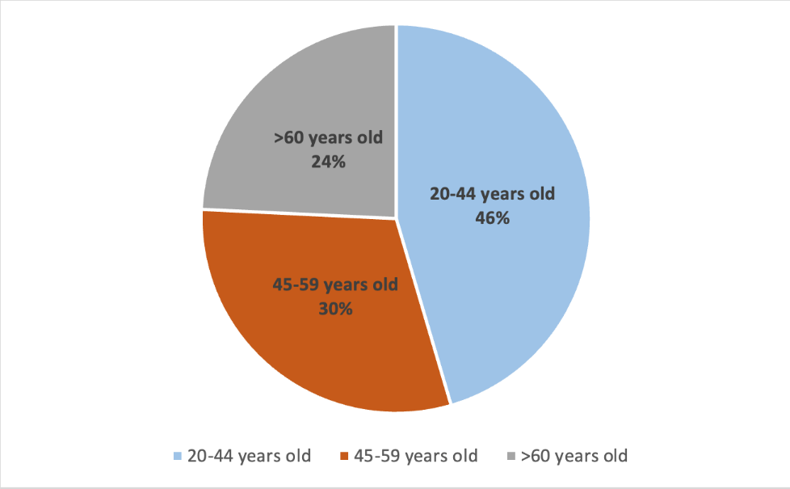

Diagram 1. The frequency distribution of age in patients diagnosed with drug-resistant pulmonary tuberculosis who received BPaL/M regimen at Dr. H. Abdul Moeloek General Hospital Lampung Province (2024-2025)

Type of Resistance

There are two types of resistance in DR-TB: primary resistance and secondary resistance (Kemenkes RI 2023). The frequency of resistance types in patients diagnosed with drug-resistant pulmonary tuberculosis who received BPaL/M regimen at Dr. H. Abdul Moeloek General Hospital Lampung Province (2024-2025) can be seen in Table 2.

Tabel 2. The Frequency of resistance types in patients diagnosed with drug-resistant pulmonary tuberculosis who received BPaL/M regimen at Dr. H. Abdul Moeloek General Hospital Lampung Province (2024-2025)

|  |  |  |
| --- | --- | --- |
| DR-TB patient | Type of Resistance | |
| Primary Resistance | Secondary Resistance |
| Number of Patient | 19 | 14 |
| Total | 33 patient | |

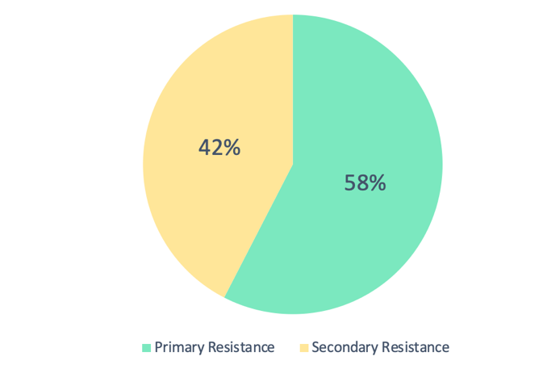

Diagram 2. The frequency of resistance types in patients diagnosed with drug-resistant pulmonary tuberculosis who received BPaL/M regimen at Dr. H. Abdul Moeloek General Hospital Lampung Province (2024-2025).

Drug Sensitization Test

The criteria for patients who can be given BPaLM regimen are patients with RR/MDR TB. The results of the fluoroquinolone drug sensitivity test are used to determine the use of moxifloxacin, if there is resistance to fluoroquinolones, it can be continued with a regimen without moxifloxacin (BPaL regimen).

Tabel 3. The frequency distribution of drug sensitization test results in patients diagnosed with drug-resistant pulmonary tuberculosis who received BPaL/M regimen at Dr. H. Abdul Moeloek General Hospital Lampung Province (2024-2025).

|  |  |  |  |
| --- | --- | --- | --- |
| DR-TB patient | Drug Sensitization Test | | |
| RR | MDR | Pre XDR |
| Number of patient | 21 | 7 | 5 |
| Total | 33 patients | | |

Diagram 3. The frequency distribution of drug sensitization test results in patients diagnosed with drug-resistant pulmonary tuberculosis who received BPaL/M regimen at Dr. H. Abdul Moeloek General Hospital Lampung Province (2024-2025).

Time to conversion of sputum MTB cultures and Success Rate

Culture conversion was an indicator whether patients are considered to have a good outcome or classified as failure cases (Conradie, 2022).In this study, there were 32 patients who were eligible to be assessed for median conversion because there are 1 patient had not converted but dropped out of treatment. There were 26 patients who showed sputum conversion results at the end of first month treatment, 5 patients who showed sputum conversion results at the end of second month treatment, and 1 patient who showed sputum conversion results at the end of third month 3 treatment (table 4).

|  |  |
| --- | --- |
| Conversion time | Total |
| The end of 1st month | 26 patient |
| The end of 2nd month | 5 patient |
| The end of 3d month | 1 patient |

Tabel 4. Time to conversion of sputum MTB cultures in patients diagnosed with drug-resistant pulmonary tuberculosis who received BPaL/M regimen at RSUD Dr. H. Abdul Moeloek Lampung Province (2024-2025).

The median sputum conversion in 32 patients diagnosed with drug-resistant pulmonary tuberculosis who received BPaL/M regimen at RSUD Dr. H. Abdul Moeloek Lampung Province was the end of first month. The treatment success of tuberculosis patients is the number of cured and fully treated tuberculosis cases among all treated and reported cases. The Ministry of Health of the Republic of Indonesia set the treatment success rate for DR-TB at 80% (Kemenkes RI 2023). The treatment success rate for patients diagnosed with drug-resistant pulmonary tuberculosis who received BPaL/M regimen at RSUD Dr. H. Abdul Moeloek Lampung Province in 2024-2025 was 83.9%.

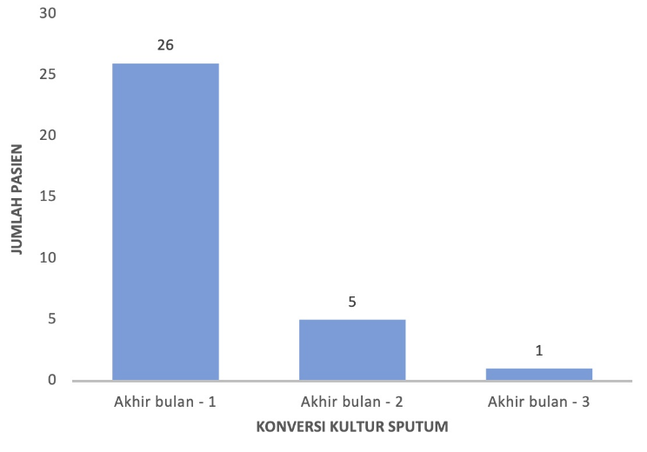

Diagram 4. Time to conversion of sputum MTB cultures in patients diagnosed with drug-resistant pulmonary tuberculosis who received BPaL/M regimen at RSUD Dr. H. Abdul Moeloek Lampung Province (2024-2025).

**DISCUSSION**

A short-term 6-month combination of Bedaquiline, Pretomanid, Linezolid, and Moxifloxacin (BPaLM) has been used since 2023 in Indonesia to treat patients with DR-TB without fluoroquinolone resistance. Documented cases of fluoroquinolone resistance can use the same combination but without moxifloxacin (BPaLM) (Putra, 2024). Before starting treatment and during treatment, patients need to conduct various examinations including bacteriological examinations, specifically acid-fast stain and sputum culture. Acid-fast and sputum culture examinations are performed at the beginning of treatment, repeated at the end of each month of treatment and at the end of treatment (Kemenkes RI, 2023). BPaL/M combination can be given to adults and adolescents >14 years of age regardless of HIV status. The characteristics of patients with drug-resistant tuberculosis who received BPaL/M regimen at RSUD Dr. H. Abdul Moeloek Lampung Province were mostly in the productive age group, i.e. the age range of 20-44 years with a total of 15 patients or 46%.

There are two types of resistance in DR-TB: new resistance and secondary resistance. New resistance pattern is resistance to anti-tuberculosis drugs (ATD) in patients who have never received TB treatment before or have received OAT for less than 1 month or called primary cases. Meanwhile, resistance that occurs in patients who have received OAT treatment for more than 1 month, patients who have failed treatment, relapsed patients or dropped out of treatment is called a secondary case. The characteristics of patients with drug-resistant tuberculosis who received BPaL/M regimen at RSUD Dr. H. Abdul Moeloek Lampung Province were mostly primary resistant group with a total of 19 patients or 58%. The characteristics of the results of the drug sensitization test were most in the rifampicine resistant (RR) group with a total of 21 patients or 64%.

Culture conversion was defined as at least two consecutive negative culture samples obtained with an interval of at least 7 days. Patients are considered to have a good outcome if they remain culture negative during treatment until the end of the advanced phase and are otherwise classified as treatment failure cases (Conradie, 2022). In this study, patients with drug-resistant tuberculosis at Dr. H. Abdul Moeloek General Hospital Lampung Province had a median sputum conversion at the end of month 1 treatment, with a therapeutic success rate of 83.9%. This result is exceeds the target set by the Indonesian Ministry of Health.

The results in this study are in accordance with previous studies. In a randomized clinical trial study conducted by Conradie, et al in patients using BPAL/M regimen showed the median sputum culture conversion time was 4 weeks and the treatment success rate (favorable outcome) in patients using BPAL/M regimen was 93% (Conradie, 2022). In Sangsayuh's case control study in 2024, the BPaL/M regimen provided rapid sputum conversion (around 4-5 weeks) and most patients achieved conversion in ≤ 8 weeks except patients with extensive lesions and large cavities who may require extended treatment duration (Sangsayunh, 2023). In a study in Indonesia by Burhan, et al the success rate of patients with BPAL/M combination was 97.6% and all patients with baseline positive cultures achieved sputum conversion in ≤ 3 months (median: 32 days) (Burhan, 2025).

**CONCLUSION**

Based on the results of observations and research on the analysis of the success of BPaL/M regimen in drug-resistant tuberculosis at RSUD Dr. H. Abdul Moeloek Lampung Province in 2024 to 2025, it can be concluded that the characteristic profile of drug-resistant tuberculosis patients at Dr. H. Abdul Moeloek General Hospital Lampung Province in this study includes age, type of resistance, results of drug sensitivity test examination, median sputum conversion time and treatment success. The characteristics of drug-resistant tuberculosis patients were mostly in the productive age group, which is the age range of 20-44 years with a total of 15 patients or 46%. Characteristics of the type of resistance were mostly in the primary resistance group with a total of 19 patients or 58%. The characteristics of the results of the drug sensitivity test were most in the rifampicine-resistant (RR) group with a total of 21 patients or 64%. The median sputum conversion in 32 patients with DR-TB who received BPaL/M regimen at Dr. H. Abdul Moeloek General Hospital Lampung Province was the end of the 1st month, with a success rate 83.9%, this number is above the target of successful treatment of DR-TB set by the Ministry of Health of the Republic of Indonesia of 80%.

**Daftar Pustaka**

1. World Health Organization. (2025). Global tuberculosis report. *Glob. tuberculosis Rep. 2025*. Diunduh dari: <https://www.who.int/publications/i/item/9789240101531/tanggal> 3 Agustus 2025.
2. Kementrian Kesehatan Republik Indonesia. (2023). Dashboard TB Indonesia - TBC Indonesia. *Kementerian Kesehatan Republik Indonesia*. Diunduh dari: <https://tbindonesia.or.id/pustaka-tbc/dashboard/>13 Januari 2023.
3. Perhimpunan Dokter Paru Indonesia. (2021). Tuberkulosis pedoman diagnosis dan penatalaksanaan di indonesia. *(ed. 2)*. Jakarta: Perhimpunan Dokter Paru Indonesia (PDPI).
4. Brode, SK., Dwilow R., Kunimoto D., Menzies D., Khan FA. (2022). Chapter 8: Drug-resistant tuberculosis. *Can J Respir Crit Care Sleep Med*. 6(1), 109–28.
5. Green KD., Tsodikovs SG. (2013). Resistance in tuberculosis: what do we know and where can we go?. *Front Microbiol*. 4(1), 1-7.
6. Gualano G., Musso M., Mencarini P., Mosti S, et Al. (2025). Safety and effectiveness of BPaL-based paduans to treat multidrug-resistant TB: first experience of an italian tuberculosis referral hospital. *Antibiotics*. 14(7), 1-10.
7. Putra ON., Purnamasari T. (2024). BPaL/BpaLM paduan: A bright future for drug–resistant tuberculosis. *Asian Pac J Trop Med*. 17(8), 335-7.
8. Kementerian Kesehatan Republik Indonesia. (2023). Petunjuk Teknis Penatalaksanaan Tuberkulosis Resisten Obat di Indonesia. Jakarta: Kementerian Kesehatan RI.
9. Conradie F., Bagdasaryan TR., Borisov S., Howell P., Mikiashvili L., Ngubane N., et Al. (2022). Bedaquiline-Pretomanid-Linezolid Paduans for Drug-Resistant Tuberculosis. *N Engl J Med*. 387(9), 810-23.
10. Kementerian Kesehatan Republik Indonesia. (2023). Laporan Program Penanggulangan Tuberkulosis. Diunduh dari: https://www.tbindonesia.or.id/pustaka-tbc/laporan-program/tanggal 3 Agustus 2025
11. Sangsayunh P., Sanchat T., Chuchottaworn C., Cheewakul K., Rattanawai S., (2023). The use of BPaL containing paduan in the MDR/PreXDR TB treatments in Thailand. *J Clin Tuberc Other Mycobact Dis*. 3(34), 1-9.
12. Burhan E., Sugiharto J., Soemarno M., Juan A., Runtu Y, et Al. (2025). Treatment success rate and time to culture conversion under a prospective BPaL cohort study. *IJLTD Open*. 2(5), 284-90.